

The schema query for MySQL.

CREATE TABLE sales   
(   
customer_id VARCHAR(1),   
order_date DATE,   
product_id INTEGER); INSERT INTO sales   
(customer_id, order_date, product_id)  
VALUES   
('A', '2021-01-01', '1'),   
('A', '2021-01-01', '2'),   
('A', '2021-01-07', '2'),   
('A', '2021-01-10', '3'),   
('A', '2021-01-11', '3'),   
('A', '2021-01-11', '3'),   
('B', '2021-01-01', '2'),   
('B', '2021-01-02', '2'),   
('B', '2021-01-04', '1'),   
('B', '2021-01-11', '1'),   
('B', '2021-01-16', '3'),   
('B', '2021-02-01', '3'),   
('C', '2021-01-01', '3'),   
('C', '2021-01-01', '3'),   
('C', '2021-01-07', '3'); CREATE TABLE menu   
(  
product_id INTEGER,   
product_name VARCHAR(5),   
price INTEGER); INSERT INTO menu   
(product_id, product_name, price)  
VALUES   
('1', 'sushi', '10'),   
('2', 'curry', '15'),   
('3', 'ramen', '12'); CREATE TABLE members   
(  
customer_id VARCHAR(1),   
join_date DATE); INSERT INTO members   
(customer_id, join_date)  
VALUES   
('A', '2021-01-07'),   
('B', '2021-01-09');

The tables

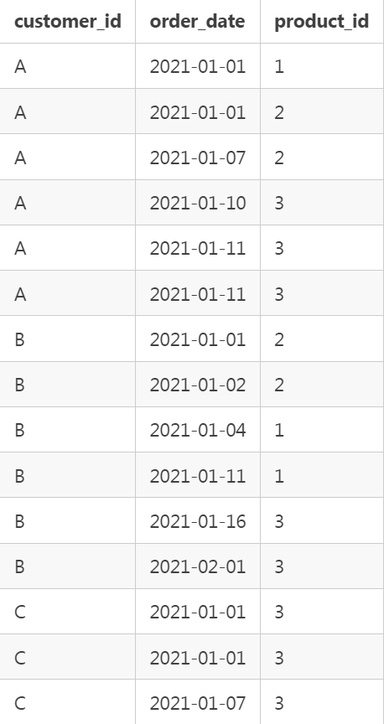

sales

menus

members

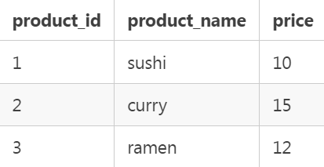

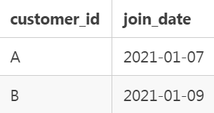

WHERE column_name comparison_operator ANY (subquery)

1. **What is the total amount each customer spent at the restaurant?**

SELECT customer_id,   
SUM(price) AS money_spent   
FROM sales   
JOIN menu   
ON menu.product_id = sales.product_id  
GROUP BY customer_id

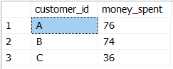

**-----------------------------------------------------------------------------------------------**

**2. How many days has each customer visited the restaurant?**

SELECT customer_id,

COUNT(DISTINCT(order_date)) AS number_of_visits  
FROM sales  
GROUP BY customer_id

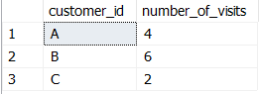

**3. What was the first item from the menu purchased by each customer?**

SELECT DISTINCT(customer_id),   
product_name FROM sales s  
JOIN menu m   
ON m.product_id = s.product_id  
WHERE s.order_date = ANY   
(  
SELECT MIN(order_date)   
FROM sales   
GROUP BY customer_id  
)

WHERE column_name comparison_operator ANY (subquery)

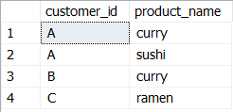

**---------------------------------------------------------------**

**4.** **What is the most purchased item on the menu and how many times was it purchased by all customers?**

SELECT top (1)

COUNT(product_name) AS count,   
product_name FROM sales s   
JOIN menu m   
ON s.product_id = m.product_id  
GROUP BY product_name   
ORDER BY count DESC



**5. Which item was the most popular for each customer?**

WITH r AS   
(  
SELECT s.customer_id,

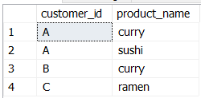m.product_name,  
COUNT(s.product_id) as count,  
DENSE_RANK() OVER (PARTITION BY s.customer_id ORDER BY COUNT(s.product_id) DESC) AS r  
FROM menu m   
JOIN sales s   
ON s.product_id = m.product_id  
GROUP BY s.customer_id, s.product_id, m.product_name  
)   
SELECT customer_id, product_name, count  
FROM r  
WHERE r = 1

DENSE_RANK() OVER (PARTITION BY expr1[{,expr2...}]

ORDER BY expr1 [ASC|DESC], [{,expr2...}])

**6. Which item was purchased first by the customer after they became a member?**

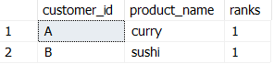WITH ranks AS  
(  
SELECT s.customer_id,  
m.product_name,  
DENSE_RANK() OVER (PARTITION BY s.customer_id ORDER BY s.order_date) AS ranks  
FROM sales s  
JOIN menu m ON s.product_id = m.product_id  
JOIN members AS mem  
ON mem.customer_id = s.customer_id  
WHERE s.order_date >= mem.join_date  
)  
SELECT * FROM ranks  
WHERE ranks = 1

DENSE_RANK() OVER (PARTITION BY expr1[{,expr2...}]

ORDER BY expr1 [ASC|DESC], [{,expr2...}])

-----------------------------------------------------------------------------------------------

**7. Which item was purchased just before the customer became a member?**

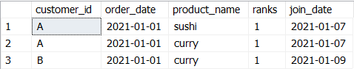WITH ranks AS  
(  
SELECT s.customer_id,  
s.order_date,  
m.product_name,  
DENSE_RANK() OVER (PARTITION BY s.customer_id ORDER BY s.order_date) AS ranks, mem.join_date  
FROM sales s  
JOIN menu m ON s.product_id = m.product_id  
JOIN members AS mem  
ON mem.customer_id = s.customer_id  
WHERE s.order_date < mem.join_date  
)  
SELECT * FROM ranks  
WHERE ranks = 1

DENSE_RANK() OVER (PARTITION BY expr1[{,expr2...}]

ORDER BY expr1 [ASC|DESC], [{,expr2...}])

**8. What is the total items and amount spent for each member before they became a member?**

SELECT s.customer_id,  
count(s.product_id) AS total_items,   
SUM(price) AS money_spent  
FROM sales AS s  
JOIN menu AS m   
ON m.product_id = s.product_id  
JOIN members AS mem   
ON s.customer_id = mem.customer_id  
WHERE s.order_date < mem.join_date  
GROUP BY s.customer_id

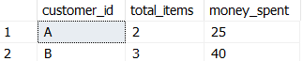

-----------------------------------------------------------------------------------------------

**9. If each $1 spent equates to 10 points and sushi has a 2x points multiplier — how many points would each customer have?**

WITH points AS   
(  
SELECT *,  
CASE   
WHEN m.product_name = 'sushi' THEN price * 20  
WHEN m.product_name != 'sushi' THEN price * 10  
END AS points  
FROM menu m  
)  
SELECT customer_id, SUM(points) AS points  
FROM sales s  
JOIN points p ON p.product_id = s.product_id  
GROUP BY s.customer_id

CASE expression

WHEN when_expression_1 THEN

result_1

WHEN when_expression_2 THEN

result_2

WHEN when_expression_3 THEN

result_3

...

ELSE

else_result

END

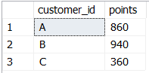

**10. In the first week after a customer joins the program (including their join date) they earn 2x points on all items, not just sushi — how many points do customer A and B have at the end of January?**

select customer_id,  
sum(points) points  
from (select s.customer_id,  
case

when product_name = 'sushi' and  
s.order_date between dateadd(day,-1,ms.join_date) and dateadd(day, 6, ms.join_date) then m.price*40  
when product_name = 'sushi' or  
s.order_date between dateadd(day,-1,ms.join_date) and dateadd(day, 6, ms.join_date) then m.price*20  
else price*10 end points  
from members ms  
left join sales s on s.customer_id = ms.customer_id  
left join menu m on s.product_id = m.product_id  
where s.order_date <= '20210131') a  
group by customer_id;

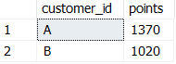

**Bonus Questions**

1. **Recreate the table**

SELECT s.customer_id,  
s.order_date,  
m.product_name,  
m.price,  
CASE   
WHEN s.order_date >= mem.join_date THEN 'Y'  
ELSE 'N'   
END AS member  
FROM sales s  
LEFT JOIN menu m ON m.product_id = s.product_id  
LEFT JOIN members mem ON mem.customer_id = s.customer_id  
ORDER BY customer_id, order_date, price DESC

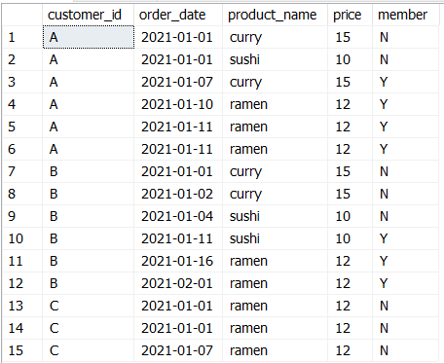

**2. Rank Members — fill non-members with null**

select *,

case when member = 'Y' then rank() over (partition by customer_id, member order by order_date)

else NULL end ranking

from (select s.customer_id,

s.order_date,

m.product_name,

m.price,

case when s.order_date >= ms.join_date then 'Y'

else 'N' end member

from sales s

left join menu m on s.product_id = m.product_id

left join members ms on s.customer_id = ms.customer_id) a

order by customer_id, order_date, product_name;

